**Azure Project Case Study**

1. **Template to create storage account with SKU restrictions, encryption enabled and allowed https access only.**

Below are the steps:

STEP 1: Open Azure Portal and go to the Deploy a custom Template 🡪 Build your own template in the template editor . I have attached the screenshots of the template below.

Screenshot 1:

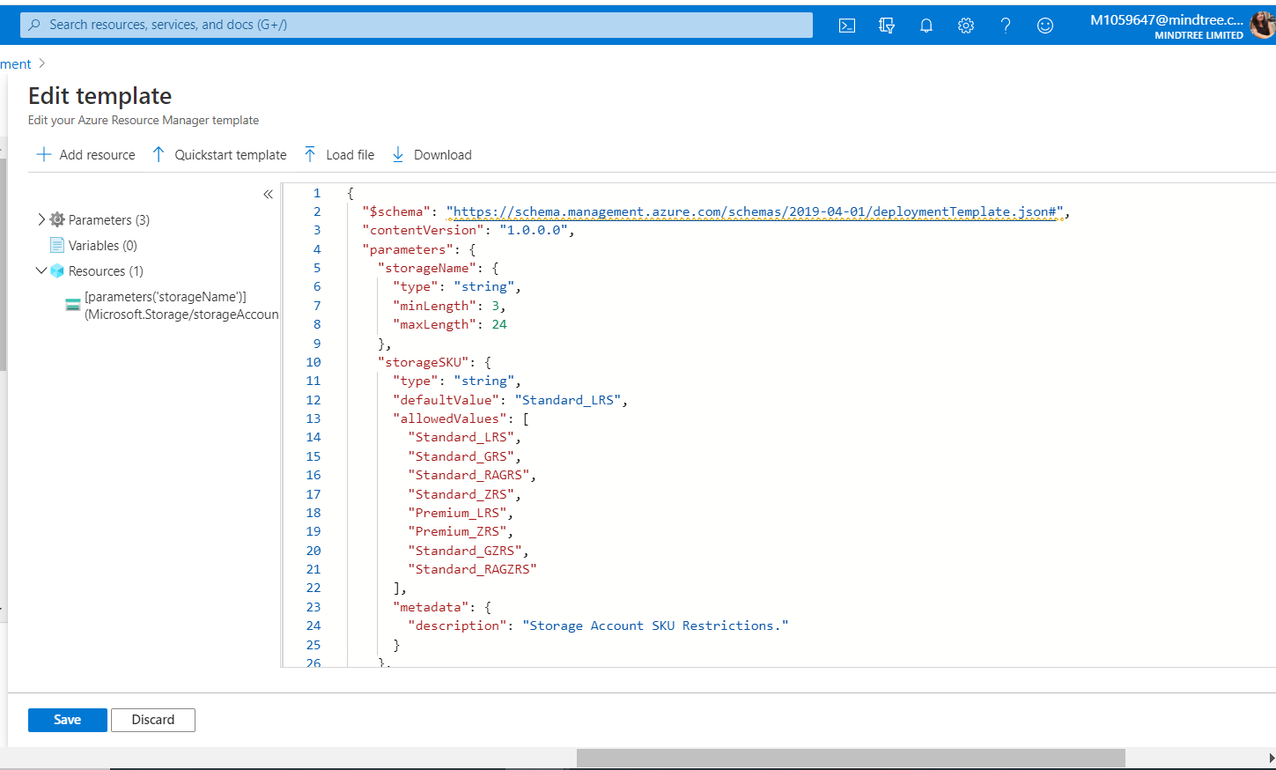

Screenshot 2:

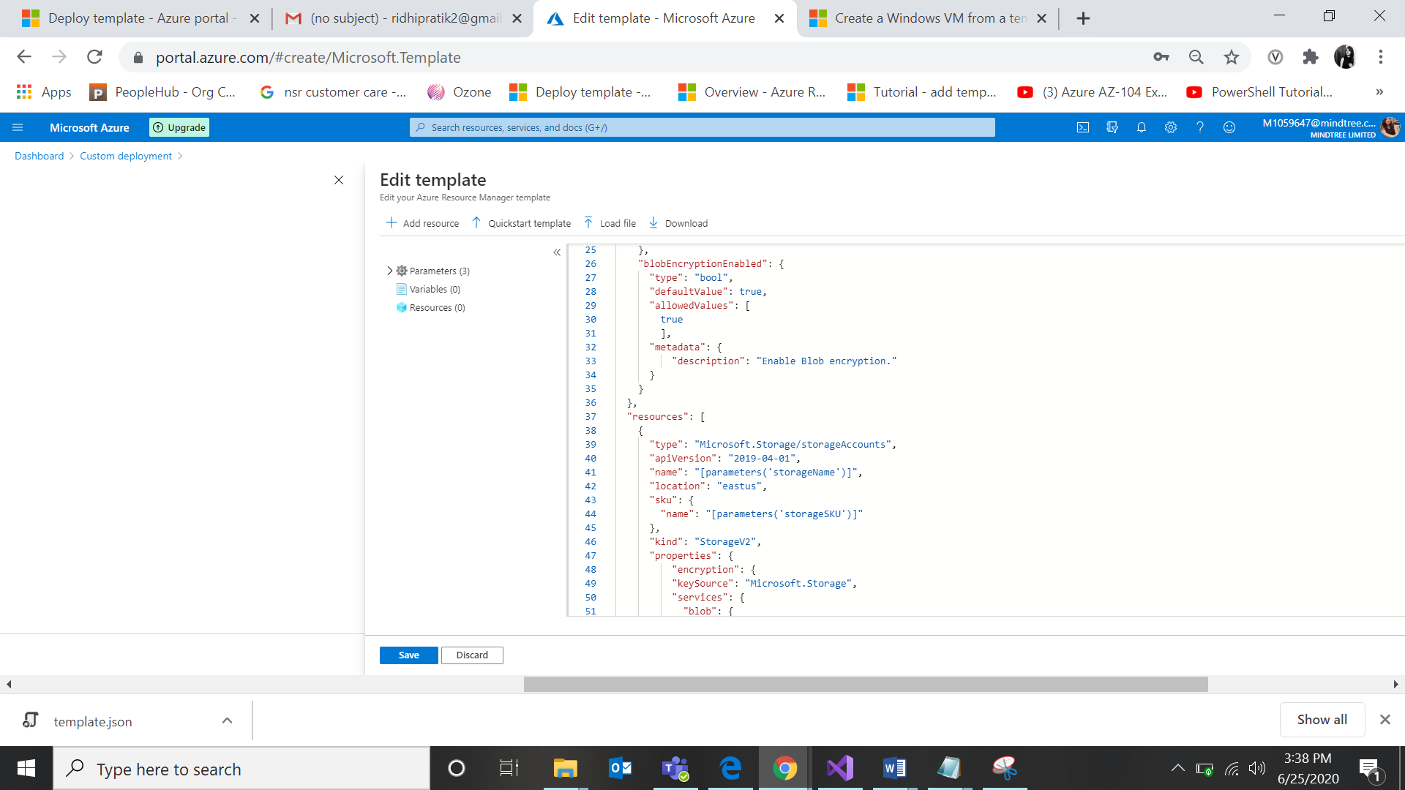

Screenshot 3:

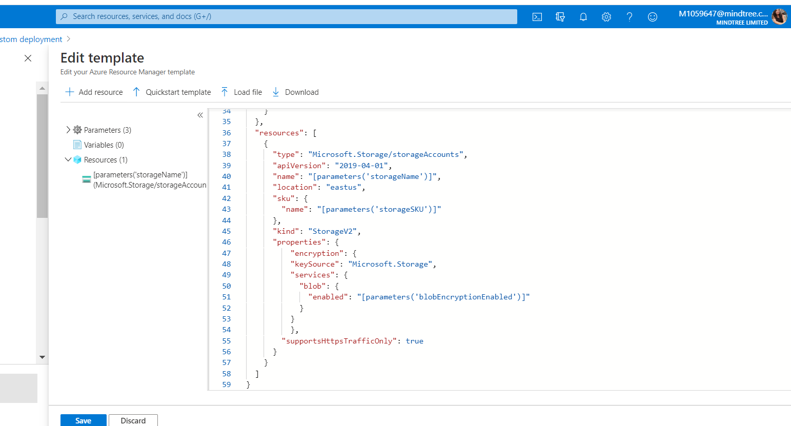

Screenshot 4:

Storage account with the name storage020397 has been created .

